The mass-storage options for embedded devices have a great impact on the rest of the system in terms of robustness, speed, and methods of in-field updates. Most devices employ flash memory in some form or other. Flash memory has become much less expensive over the past few years as storage capacities have increased from tens of megabytes to tens of gigabytes.

Embedded devices need storage that:
- takes little power and
- is physically compact,
- robust, and
- reliable over a lifetime of perhaps tens of years.

In almost all cases, this means solid-state storage.

There have been several generations of flash memory in that time, progressing from NOR to NAND to managed flash such as eMMC.

NOR flash is expensive but reliable and can be mapped into the CPU address space, which allows you to execute code directly from flash. NOR flash chips are low capacity, ranging from a few megabytes to a gigabyte or so.
NAND flash memory is much cheaper than NOR and is available in higher capacities, in the range of tens of megabytes to tens of gigabytes. However, it needs a lot of hardware and software support to turn it into a useful storage medium.
Managed flash memory consists of one or more NAND flash chips packaged with a controller that handles the complexities of flash memory and presents a hardware interface similar to that of a hard disk. The attraction is that it removes complexity from the driver software and insulates the system designer from the frequent changes in flash technology. SD cards, eMMC chips, and USB flash drives fit into this category.

NOR Flash

The memory cells in NOR flash chips are arranged into erase blocks of, for example, 128 KiB. Erasing a block sets all the bits to 1. It can be programmed one word at a time (8, 16, or 32 bits, depending on the data bus width). Each erase cycle damages the memory cells slightly, and after a number of cycles, the erase block becomes unreliable and cannot be used anymore. The maximum number of erase cycles should be given in the data sheet for the chip but is usually in the range of 100K to 1M.

The data can be read word by word. The chip is usually mapped into the CPU address space, which means that you can execute code directly from NOR flash. This makes it a convenient place to put the bootloader code as it needs no initialization beyond hardwiring the address mapping.

The kernel, and even the root filesystem, can also be located in flash memory, avoiding the need for copying them into RAM, and thus creating devices with small memory footprints. The technique is known as eXecute In Place, or XIP.
There is a standard register-level interface for NOR flash chips called the Common Flash Interface or CFI, which all modern chips support.

NAND Flash
NAND flash is much cheaper than NOR flash and has a higher capacity. First-generation NAND chips stored one bit per memory cell in what is now known as an SLC or single-level cell organization. Later generations moved on to two bits per cell in multi-level cell (MLC) chips and now to three bits per cell in tri-level cell (TLC) chips. As the number of bits per cell has increased, the reliability of the storage has decreased, requiring more complex controller hardware and software to compensate. Where reliability is a concern, you should make sure you are using SLC NAND flash chips.
NAND flash is organized into erase blocks ranging in size from 16 KiB to 512 KiB and, once again, erasing a block sets all the bits to 1. However, the number of erase cycles before the block becomes unreliable is lower, typically as few as 1K cycles for TLC chips and up to 100K for SLC. NAND flash can only be read and written in pages, usually of 2 or 4 KiB. Since they cannot be accessed byte-by-byte, they cannot be mapped into the address space and so code and data have to be copied into RAM before they can be accessed.

Data transfers to and from the chip are prone to bit flips, which can be detected and corrected using error-correction codes (ECCs). SLC chips generally use a simple Hamming code, which can be implemented efficiently in software and can correct a single-bit error in a page read. MLC and TLC chips need more sophisticated codes, such as Bose-Chaudhuri-Hocquenghem (BCH), which can correct up to 8-bit errors per page. These need hardware support.
The ECCs have to be stored somewhere, and so there is an extra area of memory per page known as the out-of-band (OOB) area, or the spare area. SLC designs usually have 1 byte of OOB per 32 bytes of main storage, so for a 2 KiB page device, the OOB is 64 bytes per page, and for a 4 KiB page, it is 128 bytes. MLC and TLC chips have proportionally larger OOB areas to accommodate more complex ECCs.

During production, the manufacturer tests all the blocks and marks any that fail by setting a flag in the OOB area of each page in the block. It is not uncommon to find that brand new chips have up to 2% of their blocks marked bad in this way.

After space has been taken in the OOB area for a bad block flag and ECC bytes, there are still some bytes left. Some flash filesystems make use of these free bytes to store filesystem metadata.

Access to NAND flash chips requires a NAND flash controller, which is usually part of the SoC. You will need the corresponding driver in the bootloader and kernel. The NAND flash controller handles the hardware interface to the chip, transferring data to and from pages, and may include hardware for error correction.

There is a standard register-level interface for NAND flash chips known as the Open NAND Flash Interface or ONFi.

Managed Flash

U-boot and Flash

The bootloader must have the drivers and infrastructure needed to support read, erase, and write operations on the type of memory you have, whether it be NOR, NAND, or managed.

U-Boot and NOR flash
U-Boot has drivers for NOR CFI chips in drivers/mtd and has the commands erase to erase memory and cp.b to copy data byte by byte, programming the flash cells.

Eg:
U-Boot# tftpboot 100000 uImage
U-Boot# erase 40040000 403fffff
U-Boot# cp.b 100000 40040000 $(filesize)

U-Boot and NAND flash
For NAND flash, you need a driver for the NAND flash controller on your SoC, which you can find in the U-Boot source code in the directory drivers/mtd/nand. You use the nand command to manage the memory using the sub-commands erase, write, and read.

Eg:
U-Boot# tftpboot 82000000 uImage
U-Boot# nand erase 280000 400000
U-Boot# nand write 82000000 280000 $(filesize)
U-Boot can also read files stored in the JFFS2, YAFFS2, and UBIFS filesystems.

U-Boot and MMC, SD, and eMMC
U-Boot has drivers for several MMC controllers in drivers/mmc. You can access the raw data using mmc read and mmc write at the user interface level, which allows you to handle raw kernel and filesystem images.
U-boot can also read files from the FAT32 and ext4 filesystems on MMC storage.

Accessing flash memory from Linux

Raw NOR and NAND flash memory is handled by the Memory Technology Device subsystem, or MTD, which provides basic interfaces to read, erase, and write blocks of flash memory. In the case of NAND flash, there are also functions to handle the OOB area and to identify bad blocks.

For managed flash, you need drivers to handle the particular hardware interface. MMC/SD cards and eMMC use the mmcblk driver; CompactFlash and hard drives use the SCSI disk driver, sd. USB flash drives use the usb_storage driver together with the sd driver.

Memory technology devices
MTD consists of three layers: a core set of functions, a set of drivers for various types of chips, and user-level drivers that present the flash memory as a character device or a block device, as shown in the following diagram:
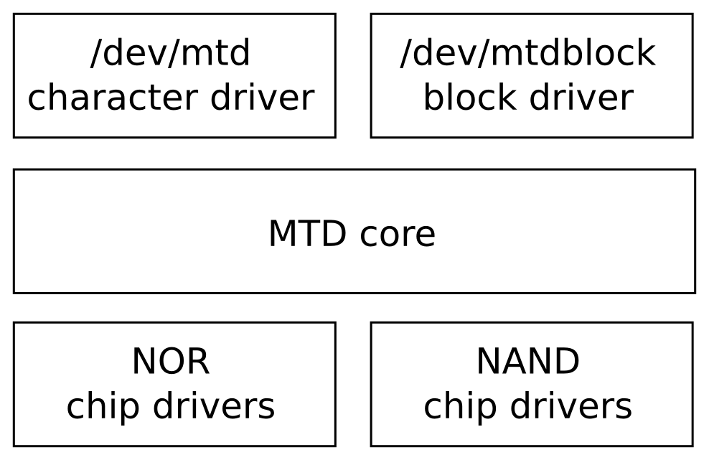

The chip drivers are at the lowest level and interface with flash chips. Only a small number of drivers are needed for NOR flash chips, enough to cover the CFI standard and variations. For NAND flash, you will need a driver for the NAND flash controller you are using; this is usually supplied as part of the board support package. There are drivers for about 40 of them in the current mainline kernel in the directory drivers/mtd/nand.

MTD partitions
In most cases, you will want to partition the flash memory into a number of areas, for example, to provide space for a bootloader, a kernel image, or a root filesystem. In MTD, there are several ways to specify the size and location of partitions, the main ones being:
- Through the kernel command line using CONFIG_MTD_CMDLINE_PARTS
- Via the device tree using CONFIG_MTD_OF_PARTS
- With a platform-mapping driver
In the case of the first option, the kernel command-line option to use is mtdparts, which is defined in the Linux source code in drivers/mtd/cmdlinepart.c.
mtdparts=<mtddef>[;<mtddef]
<mtddef> := <mtd-id>:<partdef>[,<partdef>]
<mtd-id> := unique name for the chip
<partdef> := <size>[@<offset>][<name>][ro][lk]
<size> := size of partition OR "-" to denote all remaining
space
<offset> := offset to the start of the partition; leave blank
to follow the previous partition without any gap
<name> := '(' NAME ')'
Eg:
mtdparts=:512k(SPL)ro,780k(U-Boot)ro,128k(U-BootEnv),
4m(Kernel),-(Filesystem)
The first element, before the colon, is mtd-id, which identifies the flash chip, either by number or by the name assigned by the board support package. If there is only one chip, as here, it can be left empty. If there is more than one chip, the information for each is separated by a semicolon. Then, for each chip, there is a comma-separated list of partitions, each with a size in bytes, KiB (k) or MiB (m) and a name in parentheses. The ro suffix makes the partition read-only to MTD and is often used to prevent accidental overwriting of the bootloader. The size of the last partition for the chip may be replaced by a dash (-), indicating that it should take up all the remaining space.
You can see a summary of the configuration at runtime by reading /proc/mtd.
There is more detailed information for each partition in /sys/class/mtd, including the erase block size and the page size, and it is nicely summarized using mtdinfo:
Another way of specifying MTD partitions is through the device tree. Here is an example that creates the same partitions as the command-line example:
nand@0,0 {
#address-cells = <1>;
#size-cells = <1>;
partition@0 {
label = "SPL";
reg = <0 0x80000>;
};
partition@80000 {
label = "U-Boot";
reg = <0x80000 0xc3000>;
};
partition@143000 {
label = "U-BootEnv";
reg = <0x143000 0x20000>;
};
partition@163000 {
label = "Kernel";
reg = <0x163000 0x400000>;
};
partition@563000 {
label = "Filesystem";
reg = <0x563000 0x7a9d000>;
};
};

A third alternative is to code the partition information as platform data in an mtd_partition structure. Platform data is deprecated: you will only find it used in BSPs for old SoCs that have not been updated to use a device tree.

MTD device drivers
The upper level of the MTD subsystem is a pair of device drivers:
- A character device, with a major number of 90. There are two device nodes per MTD partition number, N: /dev/mtdN (minor number=N*2) and /dev/mtdNro (minor number=(N*2 + 1)). The latter is just a read-only version of the former.
- A block device, with a major number of 31 and a minor number of N. The device nodes are in the form /dev/mtdblockN.

The MTD character device, mtd
The character devices are the most important: they allow you to access the underlying flash memory as an array of bytes so that you can read and write (program) the flash. It also implements a number of ioctl functions that allow you to erase blocks and to manage the OOB area on NAND chips.

There is a set of utility programs known as mtd-utils for manipulating flash memory that makes use of these ioctl functions.
- flash_erase: Erases a range of blocks.
- flash_lock: Locks a range of blocks.
- flash_unlock: Unlocks a range of blocks.
- nanddump: Dumps memory from NAND flash, optionally including the OOB area. Skips bad blocks.
- nandtest: Tests and diagnostics for NAND flash.
- nandwrite: Writes (programs) data from a file in to NAND flash, skipping bad blocks.

The MTD block device, mtdblock
The mtdblock driver is little used. Its purpose is to present flash memory as a block device you can use to format and mount as a filesystem. The only case where the mtdblock device is useful is to mount read-only file systems such as Squashfs on top of reliable flash memory such as NOR.
If you want a read-only filesystem on NAND flash, you should use the UBI driver.

We can write oops and kernel panics to an MTD partition as a circular log buffer. You enable it with CONFIG_MTD_OOPS and add console=ttyMTDN to the kernel command line, N being the MTD device number to write the messages to.

The MMC block driver
MMC/SD cards and eMMC chips are accessed using the mmcblk block driver. You need a host controller to match the MMC adapter you are using, which is part of the board support package. The drivers are located in the Linux source code in drivers/mmc/host.
MMC storage is partitioned using a partition table in exactly the same way you would for hard disks, using fdisk or a similar utility.

Flash translation layers
A flash translation layer has the following features:
- Sub allocation: Filesystems work best with a small allocation unit, traditionally a 512-byte sector. This is much smaller than a flash erase block of 128 KiB or more. Therefore, erase blocks have to be subdivided into smaller units to avoid wasting large amounts of space.
- Garbage collection: A consequence of suballocation is that an erase block will contain a mixture of good data and stale data after the filesystem has been in use for a while. Since we can only free up whole erase blocks, the only way to reclaim the free space is to coalesce the good data into one place and return the now empty erase block to the free list: this is garbage collection, and is usually implemented as a background thread.
- Wear leveling: There is a limit on the number of erase cycles for each block. To maximize the lifespan of a chip, it is important to move data around so that each block is erased roughly the same number of times.
- Bad block handling: On NAND flash chips, you have to avoid using any block marked bad and also mark good blocks as bad if they cannot be erased.
- Robustness: Embedded devices may be powered off or reset without warning, so any filesystem should be able to cope without corruption, usually by incorporating a journal or log of transactions.
There are several ways to deploy the flash translation layer:
- In the filesystem: as with JFFS2, YAFFS2, and UBIFS
- In the block device driver: the UBI driver, on which UBIFS depends, implements some aspects of a flash translation layer
- In the device controller: as with managed flash devices

